Massive open online courses (MOOCs) recently move into the center stage of the discourse. While MOOCs demonstrate the potential of using Internet to make education available to a broader base, the high number of enrollment and dropout for each course raise methodological difficulties for instructors to identify at-risk students and provide in-time interventions. To some extent, scaling up learning in MOOCs can be considered as a sacrifice of pedagogical support. It is almost impossible to offer the same support quality in a class of five thousand as in a class of fifty. Although a major portion of participants dropping out either are unable to engage in the course activities at all or dropping out after the first week of participation, a large fraction of participants persists in the course longer but then drop out along the way. It suggests that there are learners who are struggling to stay involved. Identifying this particular portion of struggling students and supporting their participation may become the first low hanging fruit to enhance the success of the MOOCs. In this project, we explore a series of strategies through data mining to understand how to better support MOOC learners through analytics and AI. Diagram
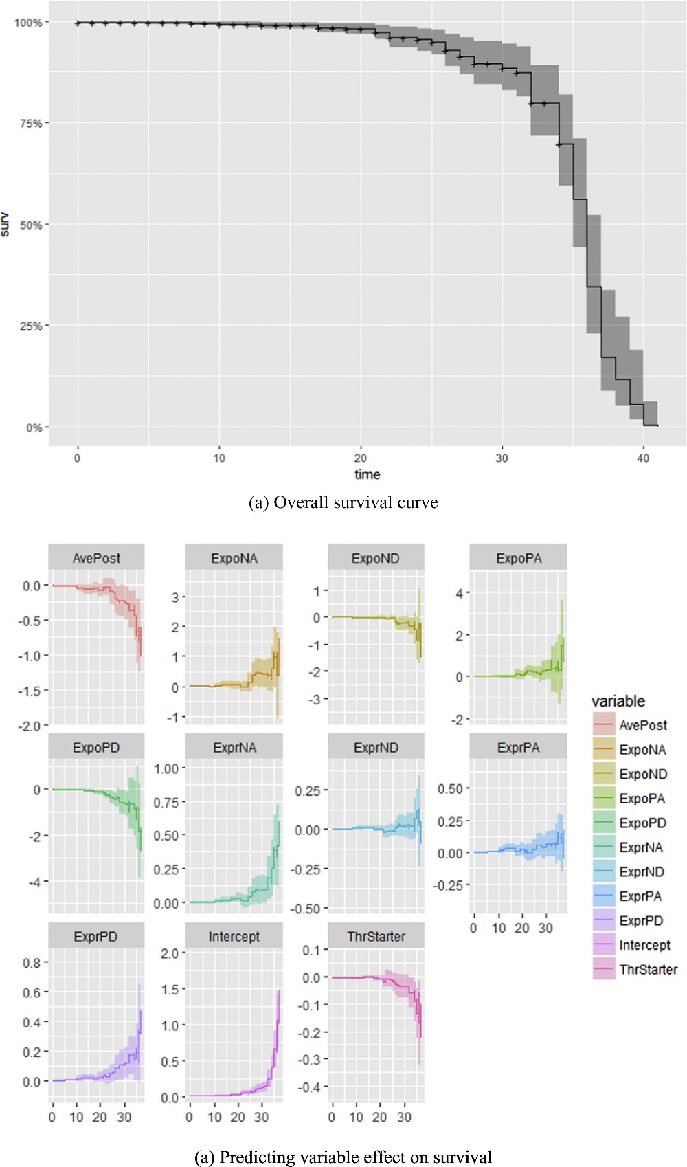

Survival analysis visualization

Publications:

Liu, B., Xing, W., Zeng, Y., & Wu, Y. (2022). Linking cognitive processes and learning outcomes: The influence of cognitive presence on learning performance in MOOCs. *British Journal of Educational Technology*.

Tang, H., & Xing, W. (2022). Massive open online courses for professional certificate programs? Perspectives on professional learners’ longitudinal participation patterns. *Australasian Journal of Educational Technology*, *38*(1), 136-147.

Liu, B., Xing, W., Zeng, Y., & Wu, Y. (2021). Quantifying the influence of achievement emotions for student learning in MOOCs. *Journal of Educational Computing Research*, *59*(3), 429-452.

Xing, W. (2019). Exploring the influences of MOOC design features on student performance and persistence. *Distance Education*, *40*(1), 98-113.

Xing, W., Tang, H., & Pei, B. (2019). Beyond positive and negative emotions: Looking into the role of achievement emotions in discussion forums of MOOCs. *The Internet and Higher Education*, *43*, 100690.

Tang, H., Xing, W., & Pei, B. (2018). Exploring the temporal dimension of forum participation in MOOCs. *Distance Education*, *39*(3), 353-372.

Xing, W., Chen, X., Stein, J., & Marcinkowski, M. (2016). Temporal predication of dropouts in MOOCs: Reaching the low hanging fruit through stacking generalization. *Computers in human behavior*, *58*, 119-129.